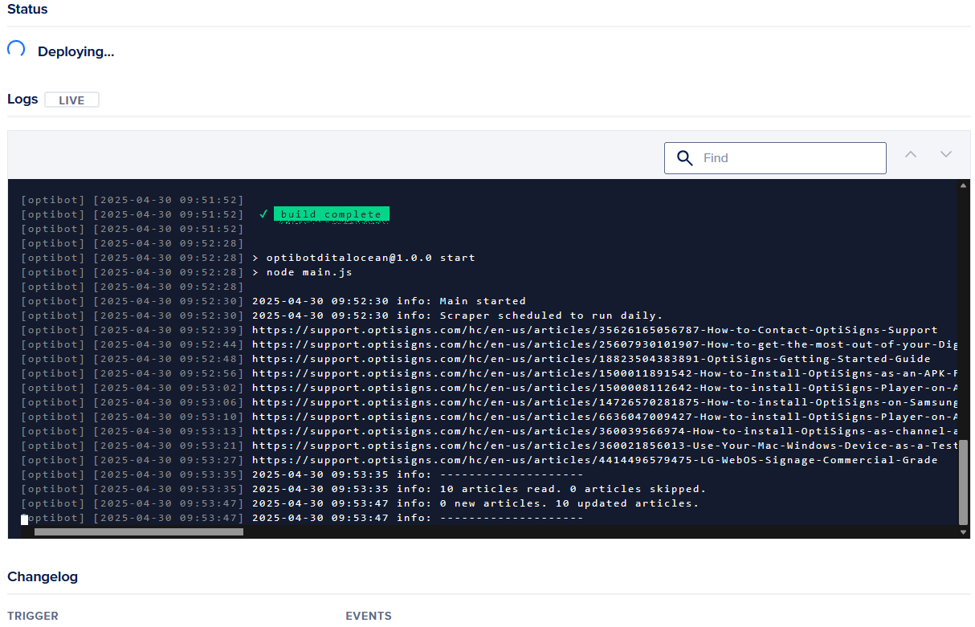

[optibot] [2025-04-30 09:50:36] ╭──────────── git repo clone ───────────╼

[optibot] [2025-04-30 09:50:36] │ › fetching app source code

[optibot] [2025-04-30 09:50:36] │ => Selecting branch "main"

[optibot] [2025-04-30 09:50:36] │ => Checking out commit "ea2dc81cae83dc10f47155ec56bbc9f6dc6786fc"

[optibot] [2025-04-30 09:50:37] │

[optibot] [2025-04-30 09:50:37] │ ✔ cloned repo to /.app_platform_workspace

[optibot] [2025-04-30 09:50:37] ╰────────────────────────────────────────╼

[optibot] [2025-04-30 09:50:37]

[optibot] [2025-04-30 09:50:37] › configuring build-time app environment variables:

[optibot] [2025-04-30 09:50:37] numArticles OPENAI_API_KEY vectorStoreId timezone APP_LOG mdFolder ASSISTANT_ID startUrl selector

[optibot] [2025-04-30 09:50:37] ╭──────────── dockerfile build ───────────╼

[optibot] [2025-04-30 09:50:37] │ › using dockerfile /.app_platform_workspace/Dockerfile

[optibot] [2025-04-30 09:50:37] │ › using build context /.app_platform_workspace//

[optibot] [2025-04-30 09:50:37] │

[optibot] [2025-04-30 09:50:37] │ INFO[0000] Retrieving image manifest node:18

[optibot] [2025-04-30 09:50:37] │ INFO[0000] Retrieving image library/node:18 from registry mirror <registry-uri-0>

[optibot] [2025-04-30 09:50:38] │ INFO[0000] Retrieving image manifest node:18

[optibot] [2025-04-30 09:50:38] │ INFO[0000] Returning cached image manifest

[optibot] [2025-04-30 09:50:38] │ INFO[0000] Built cross stage deps: map[]

[optibot] [2025-04-30 09:50:38] │ INFO[0000] Retrieving image manifest node:18

[optibot] [2025-04-30 09:50:38] │ INFO[0000] Returning cached image manifest

[optibot] [2025-04-30 09:50:38] │ INFO[0000] Retrieving image manifest node:18

[optibot] [2025-04-30 09:50:38] │ INFO[0000] Returning cached image manifest

[optibot] [2025-04-30 09:50:38] │ INFO[0000] Executing 0 build triggers

[optibot] [2025-04-30 09:50:38] │ INFO[0000] Building stage 'node:18' [idx: '0', base-idx: '-1']

[optibot] [2025-04-30 09:50:38] │ INFO[0000] Checking for cached layer <registry-uri-1>

[optibot] [2025-04-30 09:50:38] │ INFO[0000] Using caching version of cmd: RUN apt-get update && apt-get install curl gnupg -y && curl --location --silent https://dl-ssl.google.com/linux/linux_signing_key.pub | apt-key add - && sh -c 'echo "deb [arch=amd64] http://dl.google.com/linux/chrome/deb/ stable main" >> /etc/apt/sources.list.d/google.list' && apt-get update && apt-get install google-chrome-stable -y --no-install-recommends && rm -rf /var/lib/apt/lists/*

[optibot] [2025-04-30 09:50:38] │ INFO[0000] Resolving srcs [package*.json]...

[optibot] [2025-04-30 09:50:38] │ INFO[0000] Checking for cached layer <registry-uri-2>

[optibot] [2025-04-30 09:50:38] │ INFO[0000] Using caching version of cmd: RUN npm install

[optibot] [2025-04-30 09:50:38] │ INFO[0000] Cmd: EXPOSE

[optibot] [2025-04-30 09:50:38] │ INFO[0000] Adding exposed port: 8080/tcp

[optibot] [2025-04-30 09:50:38] │ INFO[0000] Unpacking rootfs as cmd COPY package*.json ./ requires it.

[optibot] [2025-04-30 09:50:50] │ INFO[0012] Initializing snapshotter ...

[optibot] [2025-04-30 09:50:50] │ INFO[0012] Taking snapshot of full filesystem...

[optibot] [2025-04-30 09:50:52] │ INFO[0015] ENV PUPPETEER_SKIP_CHROMIUM_DOWNLOAD true

[optibot] [2025-04-30 09:50:53] │ INFO[0015] No files changed in this command, skipping snapshotting.

[optibot] [2025-04-30 09:50:53] │ INFO[0015] RUN apt-get update && apt-get install curl gnupg -y && curl --location --silent https://dl-ssl.google.com/linux/linux_signing_key.pub | apt-key add - && sh -c 'echo "deb [arch=amd64] http://dl.google.com/linux/chrome/deb/ stable main" >> /etc/apt/sources.list.d/google.list' && apt-get update && apt-get install google-chrome-stable -y --no-install-recommends && rm -rf /var/lib/apt/lists/*

[optibot] [2025-04-30 09:50:53] │ INFO[0015] Found cached layer, extracting to filesystem

[optibot] [2025-04-30 09:51:16] │ INFO[0038] WORKDIR /app

[optibot] [2025-04-30 09:51:16] │ INFO[0038] Cmd: workdir

[optibot] [2025-04-30 09:51:16] │ INFO[0038] Changed working directory to /app

[optibot] [2025-04-30 09:51:16] │ INFO[0038] Creating directory /app with uid -1 and gid -1

[optibot] [2025-04-30 09:51:16] │ INFO[0038] Taking snapshot of files...

[optibot] [2025-04-30 09:51:16] │ INFO[0038] Resolving srcs [package*.json]...

[optibot] [2025-04-30 09:51:16] │ INFO[0038] COPY package*.json ./

[optibot] [2025-04-30 09:51:16] │ INFO[0038] Resolving srcs [package*.json]...

[optibot] [2025-04-30 09:51:16] │ INFO[0038] Taking snapshot of files...

[optibot] [2025-04-30 09:51:16] │ INFO[0038] RUN npm install

[optibot] [2025-04-30 09:51:16] │ INFO[0038] Found cached layer, extracting to filesystem

[optibot] [2025-04-30 09:51:51] │ INFO[0073] COPY . .

[optibot] [2025-04-30 09:51:51] │ INFO[0073] Taking snapshot of files...

[optibot] [2025-04-30 09:51:51] │ INFO[0073] EXPOSE 8080

[optibot] [2025-04-30 09:51:51] │ INFO[0073] Cmd: EXPOSE

[optibot] [2025-04-30 09:51:51] │ INFO[0073] Adding exposed port: 8080/tcp

[optibot] [2025-04-30 09:51:51] │ INFO[0073] No files changed in this command, skipping snapshotting.

[optibot] [2025-04-30 09:51:51] │ INFO[0073] CMD ["npm", "start"]

[optibot] [2025-04-30 09:51:51] │ INFO[0073] No files changed in this command, skipping snapshotting.

[optibot] [2025-04-30 09:51:51] │ INFO[0073] Pushing image to <image-3>

[optibot] [2025-04-30 09:51:52] │ INFO[0074] Pushed <registry-uri-4>

[optibot] [2025-04-30 09:51:52] │

[optibot] [2025-04-30 09:51:52] │ ✔ built and uploaded app container image to DOCR

[optibot] [2025-04-30 09:51:52] ╰──────────────────────────────────────────╼

[optibot] [2025-04-30 09:51:52]

[optibot] [2025-04-30 09:51:52] ✔ build complete

[optibot] [2025-04-30 09:51:52]

[optibot] [2025-04-30 09:52:28]

[optibot] [2025-04-30 09:52:28] > optibotditalocean@1.0.0 start

[optibot] [2025-04-30 09:52:28] > node main.js

[optibot] [2025-04-30 09:52:28]

[optibot] [2025-04-30 09:52:30] 2025-04-30 09:52:30 info: Main started

[optibot] [2025-04-30 09:52:30] 2025-04-30 09:52:30 info: Scraper scheduled to run daily.

[optibot] [2025-04-30 09:52:39] https://support.optisigns.com/hc/en-us/articles/35626165056787-How-to-Contact-OptiSigns-Support

[optibot] [2025-04-30 09:52:44] https://support.optisigns.com/hc/en-us/articles/25607930101907-How-to-get-the-most-out-of-your-Digital-Signs

[optibot] [2025-04-30 09:52:48] https://support.optisigns.com/hc/en-us/articles/18823504383891-OptiSigns-Getting-Started-Guide

[optibot] [2025-04-30 09:52:56] https://support.optisigns.com/hc/en-us/articles/1500011891542-How-to-Install-OptiSigns-as-an-APK-File-on-Android-Devices

[optibot] [2025-04-30 09:53:02] https://support.optisigns.com/hc/en-us/articles/1500008112642-How-to-install-OptiSigns-Player-on-Android-Boxes

[optibot] [2025-04-30 09:53:06] https://support.optisigns.com/hc/en-us/articles/14726570281875-How-to-install-OptiSigns-on-Samsung-Tizen-Smart-TVs

[optibot] [2025-04-30 09:53:10] https://support.optisigns.com/hc/en-us/articles/6636047009427-How-to-install-OptiSigns-Player-on-Apple-TV

[optibot] [2025-04-30 09:53:13] https://support.optisigns.com/hc/en-us/articles/360039566974-How-to-install-OptiSigns-as-channel-app-on-Roku

[optibot] [2025-04-30 09:53:21] https://support.optisigns.com/hc/en-us/articles/360021856013-Use-Your-Mac-Windows-Device-as-a-Test-Screen

[optibot] [2025-04-30 09:53:27] https://support.optisigns.com/hc/en-us/articles/4414496579475-LG-WebOS-Signage-Commercial-Grade

[optibot] [2025-04-30 09:53:35] 2025-04-30 09:53:35 info: --------------------

[optibot] [2025-04-30 09:53:35] 2025-04-30 09:53:35 info: 10 articles read. 0 articles skipped.

[optibot] [2025-04-30 09:53:47] 2025-04-30 09:53:47 info: 0 new articles. 10 updated articles.

[optibot] [2025-04-30 09:53:47] 2025-04-30 09:53:47 info: --------------------